Title of Dissertation in Mixed Case

By

Candidate Name, previous degrees

APPROVED:

___________________
AAA, PhD, Chair

___________________
BBB, PhD

___________________
CCC, PhD

___________________
DDD, PhD

Date approved: ___________________

Dissertation Format Guidelines Type Dissertation Title Here

A
Dissertation

Presented to the Faculty of
The University of Texas
Health Science Center at Houston
School of Biomedical Informatics
in Partial Fulfilment of the Requirements for the Degree of

Doctor of Philosophy

By

Candidate Name, B.A.

University of Texas Health Science Center at Houston

2012

Dissertation Committee:

Firstname Lastname, PhD¹, Advisor
Firstname Lastanme, PhD¹
Firstname Lastanme, PhD¹
Firstname Lastanme, PhD²
________________________________________________________________________
¹The School of Biomedical Informatics
²The School of Public Health

Copyright by
Candidate name
2012

Dedication

Dedicated to …This page is optional. Limit this section to 1-2 sentences.

Acknowledgements
Write a paragraph here acknowledging everyone who has helped you while you have been preparing the content of your dissertation.
This may be you supervisor or other academic staff that have provided guidance and support, other students or colleagues with whom you have collaborated on any research or project work, interviewees, librarians, or perhaps any external bodies that have given you assistance, such as access to data or the opportunity for hands on experience.

Abstract
The abstract is a summarised version of your complete paper. A reader could get the main ideas from just the abstract, or use the abstract to decide whether to read the rest of the paper. An abstract is required for all dissertations. A maximum of 500 words are recommended. Format paragraphs with the same layout used in the document.
Briefly outline what your paper aims to do.
Briefly outline the results and the conclusions you have drawn from them.
Note: Any pages which come before the content of your dissertation are given using roman numerals, with the traditional numbering starting with the Introduction on page 1. This is achieved by inserting a continuous section break at the heading for your introduction, then setting the page numbers differently for each section.

Vita
Year Degree, Field, University
Year Degree, Field, University
Year Degree, Field, University
Year to present Graduate Teaching Assistant, Department, University

Publications

Field of Study
Health Informatics

Table of Contents
Dedication ii
Acknowledgements iii
Abstract iv
Vita v
Table of Contents vi
List of Tables vii
List of Figures viii
Chapter 1: Introduction 1
Chapter 2: Article 1 2
Subheading 2
Chapter 3: Article 2 3
Chapter 4: Article 3 4
Chapter 5: Conclusions, Discussions, and Recommendations 5
References 6
Appendix A: Formatting Appendix Pages 7
Appendix B: Additional Appendix Pages 9

List of Tables

Table 1. Title for your first table
Table 2. Title for your second table

List of Figures

Figure 1. Title for your first figure
Figure 2. Title for your second figure
Figure 3. Title for your third figure

Chapter 1: Introduction
General introduction. Explain the purpose of your studies and a little background to your area of research (though not the literature review which is included in each article). This section should also explain the relationship among the various articles or parts of the research included in this dissertation.
If you are using graphs, charts or illustrations, write a paragraph introducing the figure here and then make sure each figure is numbered sequentially.

Sans Serif
Figure 1. Write a descriptive title for your illustration or graph here

Next paragraph. Introduction continues …

Chapter 2: Article 1

[Attach Article 1]

Chapter 3: Article 2

[Attach Article 2]

Chapter 4: Article 3

[Attach Article 3]

Chapter 5: Conclusions, Discussions, and Recommendations
Overall conclusions. In this section, state the conclusions for the dissertation as a whole.

References
[Since each article has its own reference list, list here only the references in Chapters 1 and 5]
Author, A. A., Author, B. B., & Author, C. C. (Year). Title of article. Title of Periodical, volume number(issue number), pages.
Author, A. A. (Year of publication). Title of work: Capital letter also for subtitle. Location: Publisher.
Author, A. A., & Author, B. B. (Date of publication). Title of article. Title of Online Periodical, volume number(issue number if available). Retrieved from
http://www.someaddress.com/full/url/
Author, A. A., & Author, B. B. (Date of publication). Title of article. Title of Journal, volume number, page range. doi:0000000/000000000000 or http://dx.doi.org/10.0000/0000
Angeli, E., Wagner, J., Lawrick, E., Moore, K., Anderson, M., Soderlund, L., & Brizee, A. (2010, May 5). General format. Retrieved from http://owl.english.purdue.edu/owl/resource/560/01/

Appendix A: Formatting Appendix Pages
[Include here only any additional appendices that relate to the manuscript as a whole. Each article may include its own appendices.]
Notice that the sequence of your appendices is given using letters ‘Appendix A’, ‘Appendix B’, etc.
Appendices contain pages and materials that do not fit logically in the body of your text or stop the flow of your document. They typically contain data tables, raw data, consent forms, programming codes, permission to use copyrighted materials, etc. Any font and text size can be used in appendix so long as it remains legible. Rules that must be followed are: 1). the word “Appendix” and a title need to appear at the top of the first page of each appendix, centered on the line, two inches down from the top edge of the paper edge, and 2). the margin requirements must be maintained with the pagination continuing unbroken. If you have multiple appendices use the following label format at the top of the first page of each appendix: Appendix A: Title, Appendix B: Title, Appendix C: Title, Appendix D: Title, etc. Label each in the order they physically appear in the document. Each appendix should be listed in the Table of Contents along with the title. Any Tables or Figures contained in the appendices must appear in the appropriate List of Tables or List of Figures.
If the use of a two inch top margin on the first page of the appendix will interfere with the formatting of the contents of that appendix, the use of a ½ Title Page as the initial appendix page is allowed. This page would appear at the beginning of the related appendix, is paginated in sequence, and contains the correct appendix identifiers (see Figure 10 below).

Appendix B: Additional Appendix Pages
With large charts and wide or long tables, some items will not fit on a standard portrait page. Landscaped pages in your document have the same margin requirements, rotated 90 degrees. The binding edge will be at the top of the illustration and remains 1.5 inches, the page number remains bottom center but in the portrait position with a one inch margin between the bottom of the page number and the left edge of the page. The other two margins remain at least one inch. The caption of the landscaped illustration is also landscape.
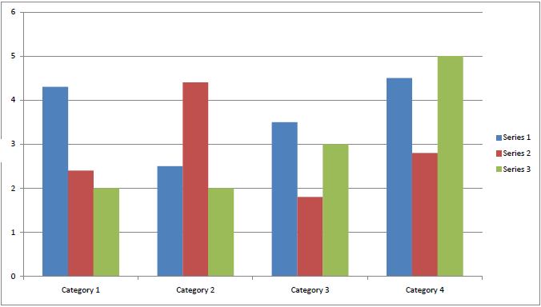
Figure 2. Sample Landscaped Figure

